**What will you get?**

For a monthly standing order or an annual payment to the Farm, you will receive:

* A personalised certificate of sponsorship.
* A colour picture and factsheet of your chosen animal.
* Entry into a prize draw to be drawn at our Spring Open Day.
* A meet and greet with your chosen animal (by arrangement).
* Your name displayed on the Farm.

**Who will you sponsor?**

You can choose from any of the animals on the Farm, small mammals are £2 per month, poultry £3 and the large animals £4 or you can make an annual payment of £20, £30 or £40 respectively.

Please specify the animal(s) that you wish to sponsor, by **circling** the amount:

|  |  |  |
| --- | --- | --- |
| **Animals** | **Monthly** | **Yearly** |
| Galaxy and friends (Guinea Pigs) | £2 | £20 |
| Chubzy and friends (Rabbits) | £2 | £20 |
| Homer and CJ (Cats) | £2 | £20 |
| Shona (Chinese Goose) | £3 | £30 |
| Colin and friends (Ducks) | £3 | £30 |
| Emma and friends (Chickens) | £3 | £30 |
| Snap, Crackle and Pop (Turkeys) | £3 | £30 |
| Ashley and Arnold (Pygmy Goats) | £4 | £40 |
| Spike, Storm and Sky (Sheep) | £4 | £40 |
|  |  |  |
|  |  |  |

**Balsall Heath City Farm**

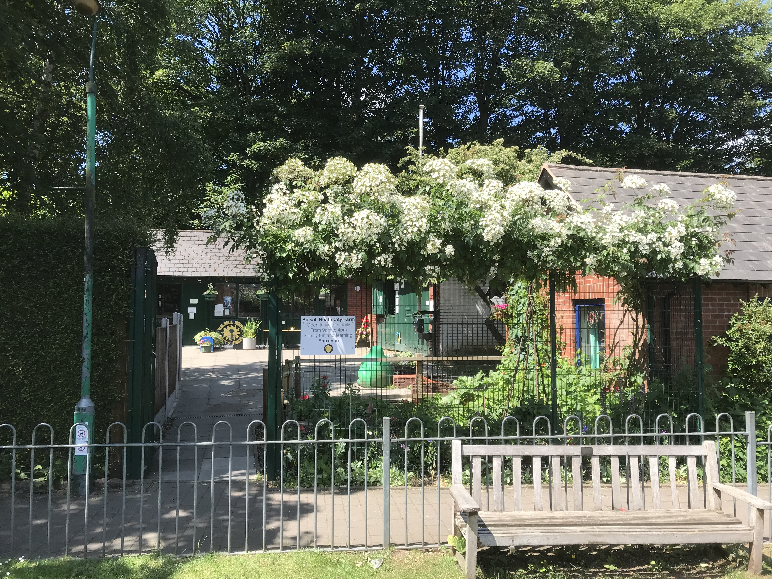

“An urban oasis for local families and groups, to learn, relax and enjoy the outdoors and meet the animals.”

Our little Farm has been on Malvern St. for nearly 40 years but receives no financial support from the City Council or other charities to care for the animals, maintain the site and keep it free to access for the community. It costs St Paul’s Trust approximately £150 per day to keep the Farm open and the Trust cannot afford to continue to support it in this way.

You can help by donating to the Farm or sponsoring an animal and contributing to the feed, bedding and veterinary costs that keep our 50 animals happy and healthy.

Children often ask for pets but once the novelty wears off, it may be you doing all the work! Why not sponsor one of our animals as an alternative to lifelong commitment to a pet at home from as little as £2 per month?

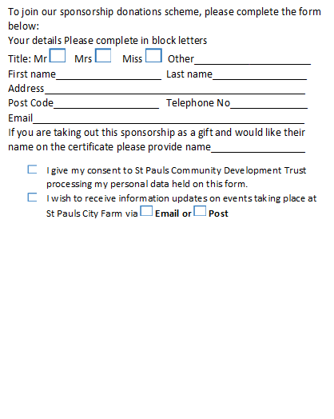

Animal  
 Sponsorship

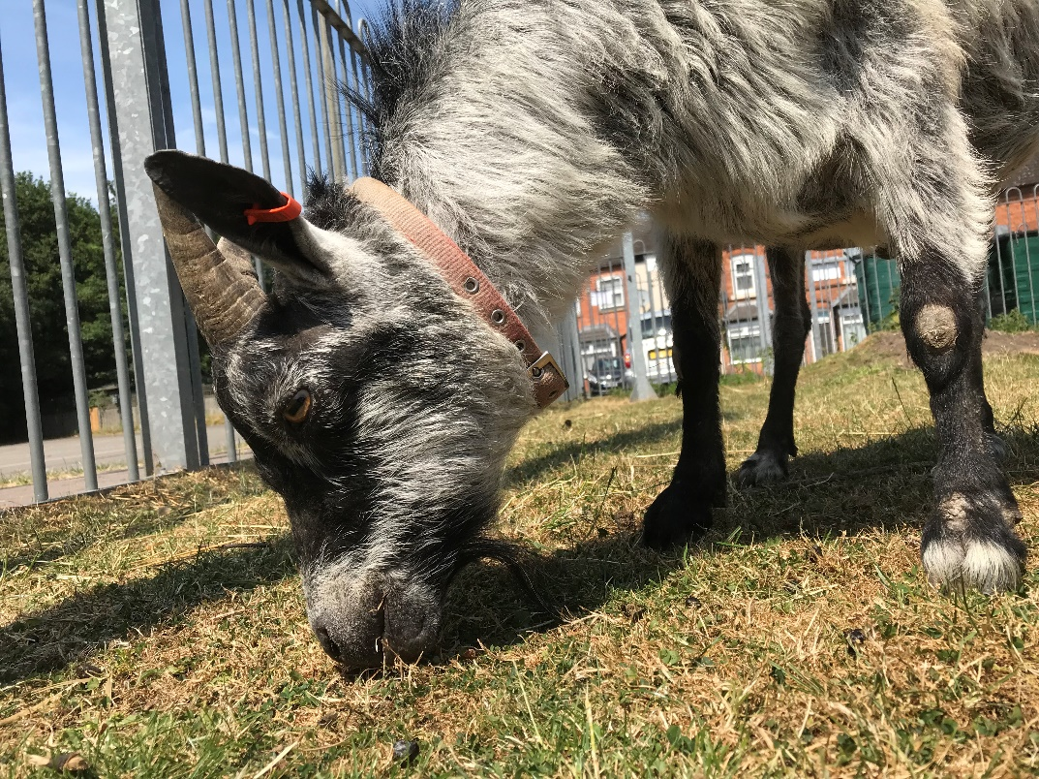

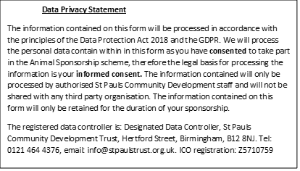



**Balsall Heath City Farm**

**St. Paul’s Trust**

You can bring your completed form to the Farm with your annual payment in cash (a receipt will be given) or set up a monthly standing order to: St. Paul’s Community Development Trust Lloyds Bank

Account number: 01117329 Sort Code: 30-94-74 Thank you!